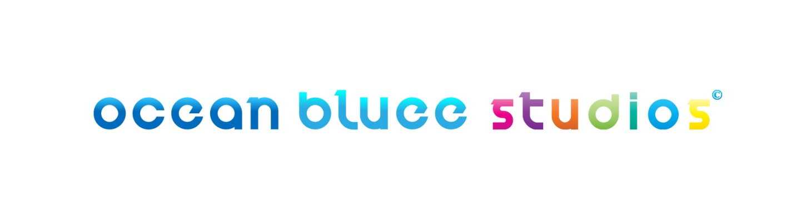

Thank you for downloading our Client Requirement Form!

You have downloaded this form that means you have something to share with us in detail.
We would like to address your “in-detail requirement” as quickly and as clearly as possible. Help us to meet your requirement by filling the below mentioned form with appropriate information.
We are always in an effort to reduce the communication stages involved in the initial project discussion.
The form enables the information you can fill in the shortest way. It will reach us and without any further ado, we will send you the Project Cost and speed up the later process till the end.

Follow few simple 3 steps mentioned below and reach us in no time:
- Answer the mandatory (* marked) questions and if feasible the optional one’s too

- Save the form under bracketed name pattern (NAME_DATE)

- Attach the form in PDF format to the email copy & send us at info@oceanbluee.com

Client Requirement Sheet
Contact Info
- Company or Individual? *:

- Your Name*:

- Company Name*:

- Designation*:

- Website URL*:

- Email ID*:
(please mention your official email id if you are approaching as a company to us)

- Address Line 1 (optional):

- Address Line 2 (optional):

- State*:

- Country*:

- Cost Currency*:
(in which currency you would like to have the project cost mentioned)

- Project Budget:
(Let us be in a WIN-WIN Situation, mention your planned budget & we will try our best to fit our production cost in it.)
* I am looking for….
☐ 3-Dimensional Animation (3D) ☐ 2-Dimensional Animation (2D)

☐ Game Modeling ☐ Photo-Real Rendering

In 3D, I require….

☐ Photo-Realistic Animation
(Attempts to resemble real life, using advanced rendering that mimics in detail skin, plants, water, fire, clouds, etc.)

☐ Motion Capture (Illuminati is tied up with some pioneer motion capture studios)
(Used when live-action actors wear special suits that allows computers to copy their movements into CG characters.)

☐ 3D Cartoon Animation
(A format in which entire character personality is catoonistic. E.g.: Finding Nemo, up etc.)

☐ 3D Model/Character Creation
(A task that consists designing/creating only still 3 dimensional models)

☐ Post Production Services
(We do Roto Scopy, Camera Tracking, Match move, Rotomation, Clean Plate, Matte Extraction, Editing, Color Correction)

Still not clear? Please share the reference video link down below, it will help us getting an access to your quality expectation.

Video Reference Link: ________________________________________________________

In 2D, I require…..

☐ Cell Animation
(Format is one of the oldest animations that have been found. E.g. Lion King, Snow White)

☐ Flash Animation

☐ Illustration/Vector Art

☐ Character Design
(A task that consists designing/creating only still 2 dimensional models)

Still not clear? Please share the reference video link down below, it will help us getting an access to your quality expectation.

Video Reference Link: ________________________________________________________
* The Project is to make…
☐ 2D Animation
☐ 3D Animation
☐ Gaming Loop Animations/ Game Trailer
☐ 3D Game Art / 2D Concept Art
☐ 3D Visualization
☐ E - Learning Presentation
☐ TVC Advertisement
☐ Explainer Video
☐ None of the above
Specify if any other: __________________________
* Other Project Details
If a Motion Picture Project, please mention the runtime you are looking for….
_ _ hours: _ _ minutes: _ _ seconds

If a Model/Character Creation Project, please mention the number of models/characters you would like to create
_______________________________________________________.
* Screen Resolution Size

☐ Small Definition (640 X 480 pixels) ☐ High Definition (1280 X 720 pixels)
☐ PAL – Television Resolution ☐ High Definition (1920 X 1080 pixels)
_
Thank you for your valuable time to fill the requirement, we will promptly get back to you within 12 working hours.

